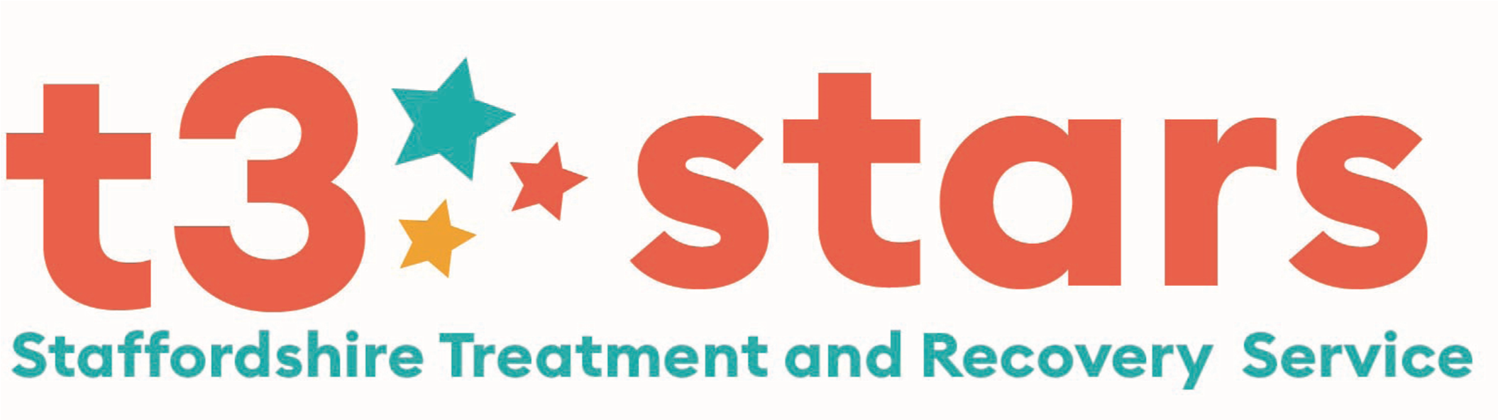
Young Person’s Substance Misuse Service
DRUG / ALCOHOL REFERRAL FORM
Fields with * MUST be Completed Please

1 | Essential Criteria for Acceptance of Referral: (if you answer ‘No’ to any of the questions in Box 1, please contact us to discuss further)  *Is the young person aware of this referral? Yes € No € & *Do they agree to this referral? Yes € No €
2 | *Are the young person’s parents/carers aware of this referral? Yes € No €  (please note: the parental consent form is required for a young person under the age of 13 years)
3 | Do you feel this young person would benefit from an initial ‘Introduction session’ to learn more about the service we offer  and how we can support them? Yes € No €
4 | Is there any preference over the gender of the key worker? Yes € No € Please detail reasons overleaf  Is an Interpreter required? Yes € No € If so, for which language? _____________________________
5 | Referrers Name: |  |  | Organisation: |  |  |  | Role:
 | Address:
 | Contact Tel No: |  |  | E Mail Address: |  |  |  | Person to contact in your absence:
6 | Client Name:  Address:  Postcode:  Contact Tel No:  Date of Birth: Age:  Gender: Ethnicity:  *Can the young person be contacted at home? Yes € No €  *Are there any risks in visiting the home? Yes € No €  Parent/Carer Name & Tel No: |  |  |  |  | Client’s Education Status:  Name of school / college:
Is the young person receiving mental health treatment?
Yes € No €
Professional working with client:

Does the young person have learning / Disability needs?
Please provide details:

 |  |  |  |  |  | GP Name/Surgery
Do The young person’s parents use substances?
Yes € No €
Please provide details:

7 | SUBSTANCE USE (Drug and alcohol)
Substances used |  | Route e.g. smoke |  |  | How much e.g. £, bags, cans, bottles |  | How often e.g. daily, 2/7, weekly, binge
8 | *SAFEGUARDING
Are there any Safeguarding concerns? Yes € No € Is the young person on a Child Protection Plan? Yes € No €

Is the young person on a Child In Need Plan? Yes € No € Is the young person a Looked After Child? Yes € No €

Social Workers name __________________________________ Contact details:_________________________________________

Please detail reason for involvement or Safeguarding concerns:

9 | *EXPLOITATION – CSE /CCE
Has a Risk Factor Matrix been completed? Yes € No € Is the young person on MACE panel? Yes € No €

Risk level on Matrix Low € Medium € High € CCE € CSE € DUAL €

Please detail reasons for Matrix being completed:

10 | OFFENDING
Is the young person involved in criminal activity Yes € No €
Is the young person at risk of becoming involved in criminal activity Yes € No €
Is the young person working with the Youth Offending Service Yes € No € Case Manager’s Name:

Please detail offence type/s, & additional information:

Continued……….

ADDITIONAL INFORMATION

Identified Risks: Safeguarding, Risks to home visiting, Risk to worker, Exploitation, overdose, injecting, offending, physical/mental health issues, binge use, & Any Other Relevant Information

Date of Completion:

We allocate referrals on Monday mornings at our allocation meetings. Following this, the young person will be contacted by a Key Worker in their area to offer an initial appointment that same week.

Please submit your referral:  By Post - Suite 1, 7-8 Mill Street, Stafford. ST16 2AJ.  Tel: 01785 241393  E mail: t3stars.stafford@humankindcharity.org.uk  liz.giles@humankindcharity.org.uk | FOR OFFICE USE ONLY:
 | Date Allocated: | Key Worker:
 | Structured € Unstructured Single €
 | 1st Appointment Offered:

April 2021

